Submission Form for practice examples and case studies on
Patient and Healthcare Worker Safety or Healthcare Safety

Section I: Background information
Submitted by:
Name/s:
Other people involved in the project
Email:
Telephone:
Website (if appropriate)
Section II:
Role of the ergonomists/human factors experts in the project:
(Project leader, ergonomist in multidisciplinary team, please describe)

Main area(s) of intervention:
(physical, cognitive, organizational ergonomics or mix)

Keywords (max 5):

What was the aim of this patient safety project (Please tie into the SEIPS 3.0 model)?
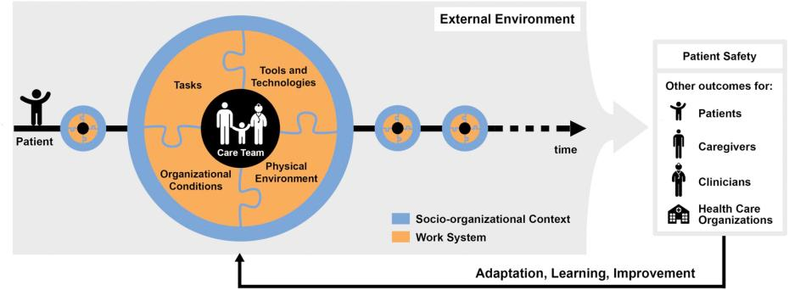

Contracting company/hospital/clinic (not essential):

Industry or sector: Health Care and Patient Safety

Section III.
Description of HOW the work was done and the OUTCOME (may contain photos, diagrams or tables). Please state the methods used and what was achieved (the result).

Was the outcome evaluated following implementation? If so, how and with what result:

Was a cost-benefit analysis done? If so, please briefly describe the results:

Any special comments:

Carayon P, Schoofs Hundt A, Karsh BT, Gurses AP, Alvarado CJ, Smith M, Flatley Brennan P. Work system design for patient safety: the SEIPS model. Qual Saf Health Care. 2006 Dec;15 Suppl 1(Suppl 1):i50-8. doi: 10.1136/qshc.2005.015842. PMID: 17142610; PMCID: PMC2464868.

Please email your summary to:
Michelle Roberston mmrobertson321@gmail.com; Susan Hallbeck hallbeckhfes@gmail.com

